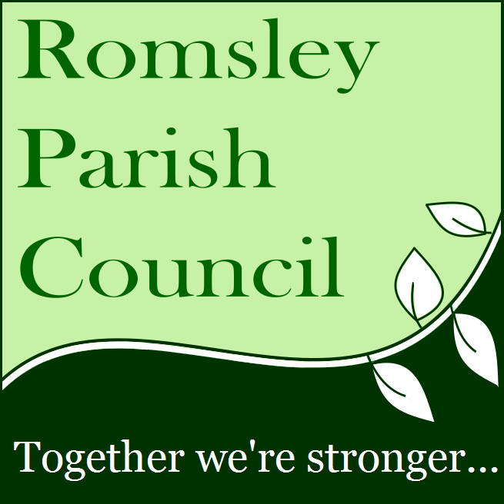
Richard Arrowsmith
Romsley Parish Council
167 Bromsgrove Road
Worcestershire
B62 0JU
01562 712050

ruth.mullett@btconnect.com
6th April 2018
To: Bromsgrove Planning Department
Cc: Margaret Sherry – District Councillor, Belbroughton and Romsley Ward
Cc: Chris Allen-Jones – District Councillor, Belbroughton and Romsley Ward
Cc: Karen May – County Councillor, Clent Hills Division

Planning application 18/00282/FUL – Seven dwellings, Yew Tree Farm, Romsley

This document is the Romsley Parish Council response to the planning application 18/00282/FUL which proposes the building of seven dwellings and associated garaging on land associated with Yew Tree Farm beside St Kenelms Road, Romsley.
As of the 6th April 2017, Romsley Parish Council objects to this planning application in its current form due to the significant traffic safety and congestion issues that currently exist at this location that would be made significantly worse by the development.
However, with suitable modification to the proposals that clearly resolve the traffic issues through changes to the road width, layout and parking arrangements, the Parish Council objection can be withdrawn.
For the public record, the Parish Council has contacted the developer on two occasions in an attempt to open a constructive dialogue about the proposed development and the modifications that would be required to alleviate community concerns. It is disappointing that the developer has not taken us up on our offers as many of the issues we now make reference to could have been removed through proper dialogue. However, we remain happy to work with the developer and relevant authorities to modify the proposals such that our objections can be removed.
Before moving onto the detail of our objection, The Parish Council would like to state that it fully recognises the obligations it carries as a branch of local Government to support the ambitious house building targets set by central Government. As such we will support appropriate and sustainable housing developments that contribute towards the community of Romsley whilst we will oppose or seek a modification to those that overtly damage the character of our village, excessively impacts upon our residents or unduly damages the rural environment that surrounds us.
This development has sparked huge interest within our community with nearly sixty public comments sitting with Bromsgrove District Council at the time of writing this response and many were copied directly to the Parish Council. Though the Parish Council is aware of a number of community concerns associated with greenbelt development we also recognise our governmental obligations and after general consideration the Parish Council believes that the Yew Tree Farm site is a legitimate location for additional housing if the proposed development meets criteria over community affordability, house & sight lines, environmental impacts, drainage and flood mitigations and traffic-related issues.
The Parish Council endorses the changes that have been made to the development against the first two criteria following intervention by the District Planning team. The Parish Council also fully endorses the requests made by the Parks & Green Space Development Officer for managing the post-development bio-diversity and the requests of the Drainage Engineer in regard to obtaining a Surface water drainage strategy for the site and making this part of the planning application assessment as localised flooding has been a significant problem for residents living in the vicinity of the development.
However, with regard to the traffic-related issues, the proposed development will make an already unsustainable traffic problem much worse and will have a massively detrimental impact on not only the lives of those living nearby but the entire Romsley community.
The location of the proposed development sits on St Kenelms Road directly opposite the Co-op convenience store and Post Office. This is an extremely busy and vital shop, at the heart of our community, which attracts large numbers of short duration visitors throughout its opening hours (7am – 10pm). The location is also just a few yards from a number of other local shops, the popular Sun Public House and a busy junction with the Bromsgrove Road. Traffic flow on St Kenelms Road is high, as it is the main access route in and out of the village centre. It also attracts significant numbers of commercial vehicles accessing the shop, local businesses and nearby farms and is a bus route for both public services as well as school vehicles.
The road layout is narrow at the location with a maximum width of just under 6 metres spread over two lanes. However, a marked parking area approximately 2.1 metres wide by 25 metres or six car lengths exists on the shop side of the road. This parking is in continuous use and effectively reduces the road to a single carriageway of less than 3.6 metres width. The road is unlit at this location, and a cul-de-sac (Kenelm Court) containing ten properties exits immediately after the shop. After this unmarked residential and shop overspill parking continues for a further 28 metres down St Kenelm’s Road all of which is in continuous use as the properties do not have driveways.
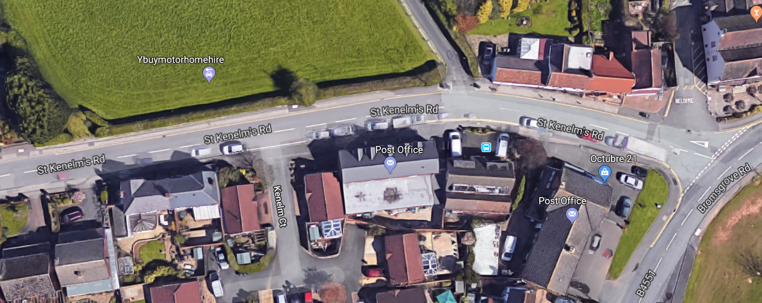
From its junction with Bromsgrove Road, St Kenelms Road contains a sweeping curve to the left which in combination with parked cars massively impacts vehicle sightlines. Very frequently (approximately thirty plus times an hour) cars meet and cannot pass because of the available width and cannot reverse because they are being followed. Pavement mounting is frequent as are driver confrontations. Pedestrians and road users are at a high and persistent risk of collision and sadly there has already been one serious road traffic collision at the location involving a cyclist who was struck and seriously injured.
Marked parking restrictions are in place but are largely ignored, and it is not feasible to enforce these across the many hours the parking problems persist. Anti-social parking is sadly commonplace with many local residents bearing the brunt of this with driveways being blocked and many receiving appalling verbal abuse if they ask people to move.
This section of road is best described as chaotic, and the problems persist from 7:30am through to 9pm seven days a week. As a result, the Parish Council has been lobbying the County Council for several years to address the problems and has also consulted the community on potential solutions. The general consensus is that the widening of the road by approximately 2.5 metres would permit an offset parking layby to be created in front of the shop whilst allowing two lanes of traffic to flow. Though this would not eradicate the problems entirely as it would not increase the number of parking bays, it would significantly improve flow and safety and is deemed to be the practical and sustainable solution that minimises impacts and costs.

The proposed housing development would see several additional drives turn on to this effectively single lane road adding to the vehicle volumes and traffic confusion. Turning on and off the new properties would be particularly problematic, and though drives have been created for all the properties, service vehicles such as bin lorries, delivery vehicles and visitor’s cars would all create serious and frequent problems. It should also be noted that during the construction phase, which could range from six to nine months, delivery traffic, plant and machinery, as well as vehicles associated with the workforce, will cause gridlock at the location and seriously affect the safety of residents and site workers.
Once completed residents will experience the same level of anti-social parking that current residents face with their drives being blocked and their own families exposed to risks associated with vehicles mounting the pavements at this location.
Finally, traffic volumes are predicted to increase, and the congestion at this location will therefore only worsen. If the development goes ahead in its current form all future opportunities to address the problems by changing the road width and layout will be lost, thus, blighting the village and its residents for generations to come.
In conclusion, the Parish Council cannot support the proposal as it stands, but we restate our offer to meet with the developer to discuss the proposal and positively explore how it can be modified to resolve the traffic issues on St Kenelms Road and ensure the development is sustainable and delivers benefits to both the developers and to the community of Romsley.

Kind Regards,
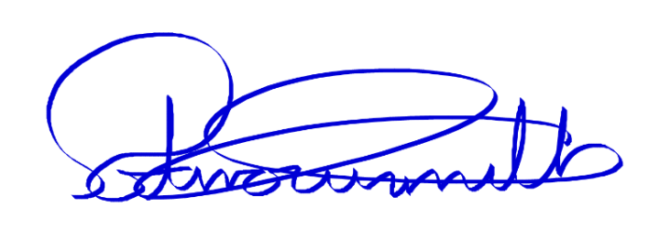
Richard Arrowsmith,
Romsley Parish Council Chairperson on behalf of Romsley Parish Council

(Photographs of typical traffic issues at location including blocked lanes and vehicle mounting the footpath are attached)

