**Use it or lose it**

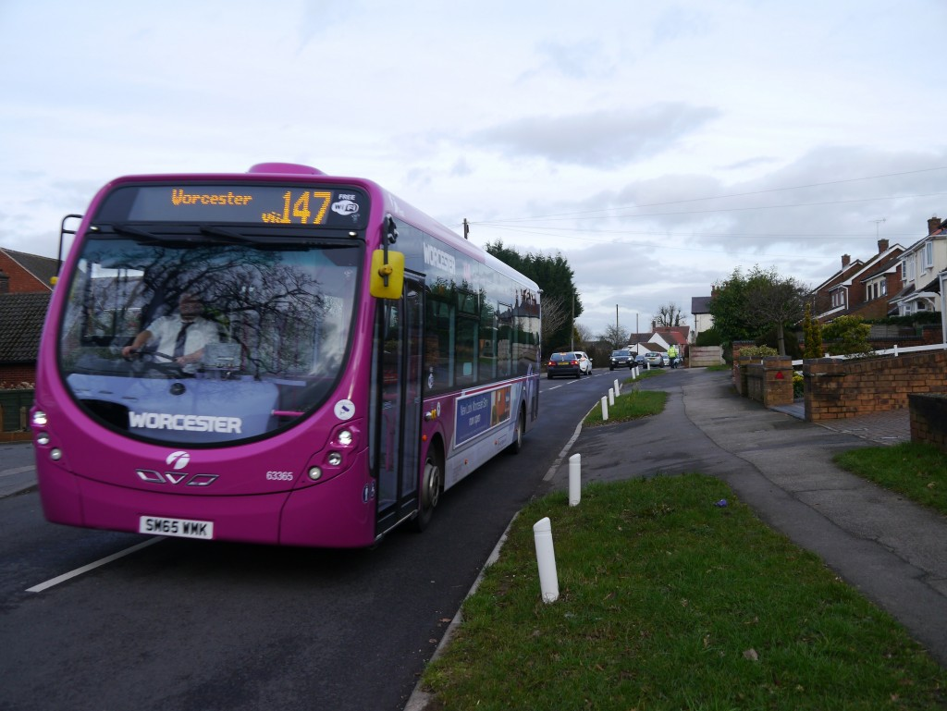

As a result of our lobbying, Worcester County Council have found the money to subsidise our bus service for six months. After this time, the use of this service will be reviewed.

If enough people use the 147 bus, we will be able to keep the service.

www.romsleyparishcouncil.gov.uk