This document is the Romsley Parish Council response to the planning application 17/00342/FUL which proposes the building of five detached dwellings on land between 15 and 25 Dark Lane, Romsley.

Romsley Parish Council objects to the planning application.

Before summarising the reasons for this objection, the Parish Council would like to inform the planning authority about the level of concern and dismay being displayed by residents over this application. At the Parish Council meeting of Monday 15th May we had over 100 residents attend to raise their concerns on this application. In the following week, residents organised two further meetings at which more than 150 residents attended. This is the largest response to a planning matter I have seen within the Parish, with the number of residents raising issue being even larger than that associated to the Severn Trent Birmingham Resilience Project of 2016.

Romsley Parish Council objects to the planning application for the following reasons

- The Parish Council believes the development is within green belt designated land. The online version of the Bromsgrove District Plan 2017 shows that the Village Envelope / Green Belt boundary passes through the proposed development, with the majority of the footprint for the buildings themselves sitting clearly outside of the Village Envelope. However, the Parish Council believes that the position of this boundary as shown on the BDP is in fact an artefact of the GIS mapping software used to provide the information for the Bromsgrove Plan and the analysis of historic records would show the field to be entirely designated Green Belt. The Parish Council request that the planning authority undertake a full examination of records to ensure this matter of the Green Belt to village envelope boundary be properly resolved.

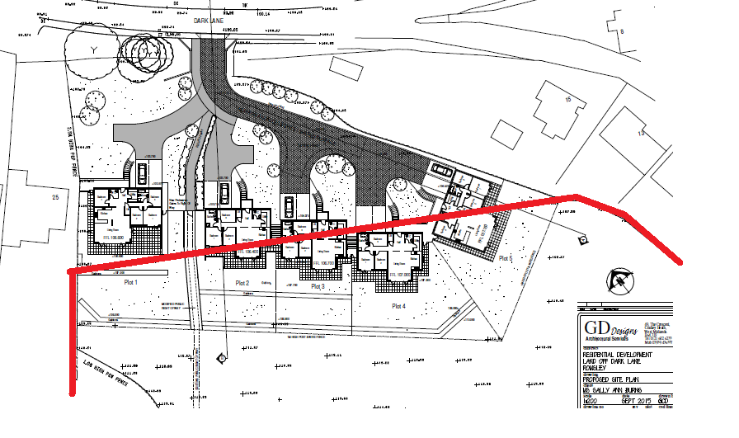
Figure 1- The green belt, village envelope boundary (red line) as indicated on the Bromsgrove District Plan 2017

- We are concerned over the substantial environmental damage the development will cause. The proposed development is within 150 metres of Site of Special Scientific Interest (SSSI) and is within a Natural England SSSI Impact Risk Zone. The site is also within 50 metres of woodland priority habitat and, in its own right, is an area of biologically diverse grassland. There are a number of protected flora species including Snake's-Head Fritillaries, and protected fauna such as Lapwings, Tree Sparrows and Common Lizards as well as multiple species of mammals including badgers. Based on the descriptions contained within the Bromsgrove District Plan (section 8.212) this area is an “environmental stepping stone” between the SSSI and other habitats within our Parish and it provides a “buffer zone” between the Village and the environment of the Romsley Hills. Given the potential environmental impacts of this development, the Parish Council believes a full and robust environmental impact assessment should be submitted before any planning application can be considered.

- The Parish Council is troubled that this development is on the only remaining "green gateway" from Romsley Village itself to the Romsley Hills. The site is known locally as the "Rolling Hills" and it is a distinct part of our local heritage. Romsley has a unique relationship with its hills, after all the majority of its residents live at 200 metres or more above sea level and we are very much a hillside community. The Rolling Hills help define our community’s cultural identity, having played a significant part in the lives of Romsley residents for generations, its loss will be desperately felt by many residents. This area of land also provides substantial social amenity as it forms part of the most used access route for villagers onto our hills. Many residents have already identified the impact that this development will have on their identity and their wellbeing.

- It should also be noted that this development will result in a substantial loss of landscape and visual amenity. The proposed development will sit on one of the highest points in the main village and will be visible to a large number of properties. Given that this development would sit upon the “Rolling Hills” and that these hills form a unique part of our Parishes’ physical landscape, the development is required to demonstrate it has accounted for the Worcestershire Landscape Character assessment, (which clearly designates the entire area to be wooded hills and farmland) and to show the development will result in landscape gain. At this time the Parish Council does believe this to be the case as the development requires removal of a significant part of the “Rolling Hill” itself to reduce the gradient from 1 in 6 to 1 in 12 and thereby fundamentally changing the physical structure of the Rolling Hill and considerably altering its “green gateway” appearance.

- A public right of way exists across the site and whilst we acknowledge this has been retained in the plans presented it must be recognised that the nature of this footpath will be changed dramatically. A long length of it would pass through a residential driveway before passing through a section that has high fences on both sides. It will no longer be a country path and its vistas and sightlines will be lost for ever as will the views from the top of the hill which will look down into the development’s properties. Given the proposed changes in the gradients on the site, the physical profile of footpath will also have to change with either a long row of steps or a much steeper gradient being introduced. Both of these changes which will affect access and thereby reduce use by the community. The Parish Council is concerned that the space left between plot 1 and plot 2 is of a deliberate width to permit an additional road to be added in at a later date to service a second development of houses that would be positioned behind those currently being proposed. This would be an intolerable example of village envelope spread into the Green Belt designated land.

- Many residents have serious concerns about the impact of this development on drainage and the Parish Council agrees that it is likely to intensify the problems we already have with localised flooding in this area of the village. Though the development is in a zone 1 flood risk area and is less than a hectare in size, it must be understood that Romsley residents are plagued with localised flooding. This is caused by the clay rich soil and multiple water courses associated with our hillside location. Dark Lane, Poplar Lane and Hillcrest Road already experience serious problems from surface water causing roads and properties to become easily flooded. Heavy rainfall runs off our hills and collects at numerous locations across the village as the old, inadequate and below capacity drainage network cannot cope. This development will significantly reduce, remove or block natural soakaways and disrupt water courses. The Parish Council believes a full hydrology and drainage study must be completed prior to any planning decision being taken and this must fully involve the relevant highways and drainage authorities to ensure that the wider network issues are factored in and existing residents are not unfairly affected.

- Dark Lane is a busy thoroughfare which already has speeds and traffic volumes that are in excess of its design and designation. The road is used as a commuter run and is particularly busy at peak periods. The proposed site is very close to the junctions of Poplar Lane, Dark Lane and Hillcrest Road, it is on the brow of a hill and on the apex of a significant bend. There are already multiple issues over driver sight lines at this location and the proposed site access is on a blind summit making entering and exiting the site hazardous.

- The Parish Council is deeply alarmed about the presentation of this development as being for disabled people in a cynical attempt to meet Bromsgrove District Council policies regarding sustainable housing. We note that no suggestion or offer for a restrictive covenant or planning condition limiting their sale to disabled people has been made by the applicant. The Parish Council also wants to ensure that all our residents are able to fully access the wider village and community. We question whether the physical site with its substantial gradients, as well as the designs of the homes themselves, will provide appropriate and safe access and egress, for people with mobility issues, to the rest of the Parish.

- As a community we welcome the building of new homes that meet the needs of Romsley residents. Going forward, we need sustainable and affordable housing built in appropriate locations and to a suitable design for our Parish. Romsley does have an aging population, some of whom do have mobility issues, and we need affordable homes that will allow older or disabled residents to continue living in their Parish. The Parish Council is currently preparing its Neighbourhood Plan to set out these requirements in more detail. However, even without our formalised Neighbourhood Plan it is clear to the Parish Council that the homes on this development will not be affordable or meet the needs of our communities older or disabled residents. What’s more, the Parish Council believes they will quickly lose their disabled home orientation and will be sold as executive homes, with no benefit being derived for our existing residents.

- Finally, the Parish Council would like to highlight the impact that the construction phase for these houses would have on the Romsley community. Due to the gradient of the land and the need to create level plinths for building, several thousand tonnes of soil will need to removed and then transported away from the site. This will involve significant and prolonged activity by heavy construction equipment and will result in upwards of 200 HGV movements to remove the soil. The impact on residents will be significant and the Parish Council believes this to be excessive and unwarranted given that our community will not benefit from an increased stock of sustainable and appropriate homes.

